Assignment 3

|  |  |
| --- | --- |
| Assignment Date | 14-11-2022 |
| Student Name | Pragadeesh |
| Student Roll Number | 111419104080 |
| Team ID | PNT2022TMID24120 |

1. Create a bucket in IBM object storage.

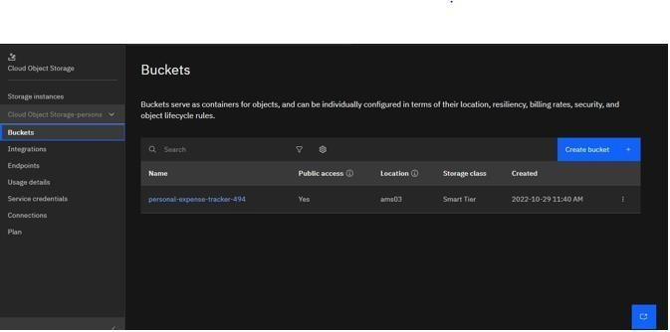

1. Upload any 5 images to IBM object storage and make it public. Write HTML code to displaying all the 5 images

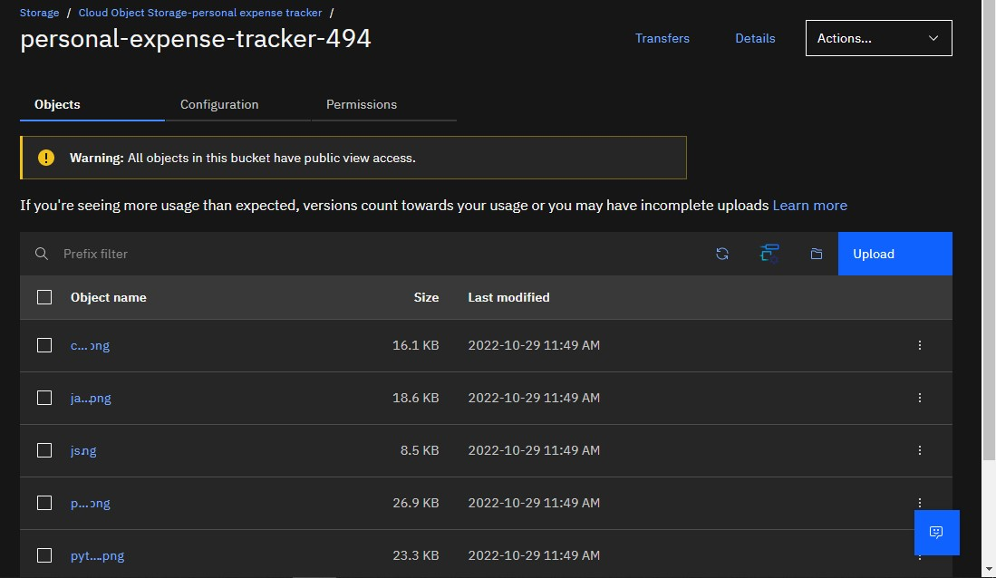

**HTML Code to display the images in IBM Object Storage**

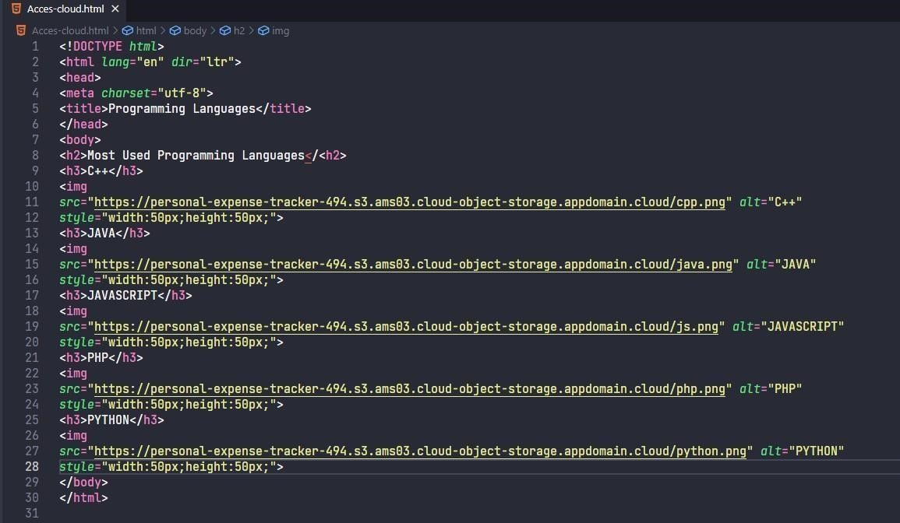

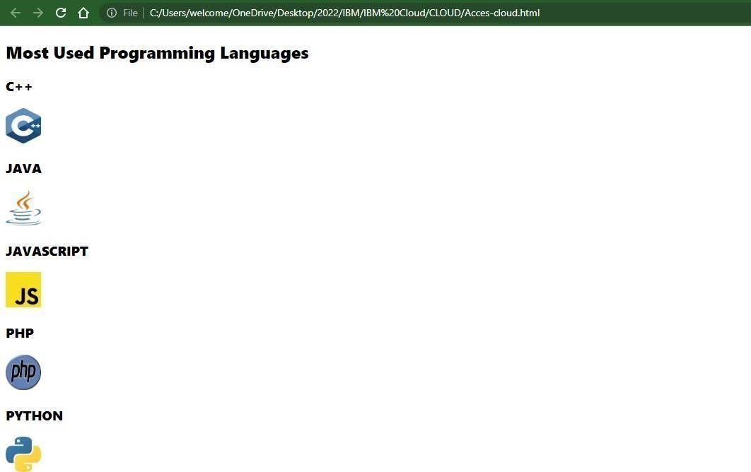

1. Uploada CSSpagetotheobject storage and use the same page inyour HTML code.

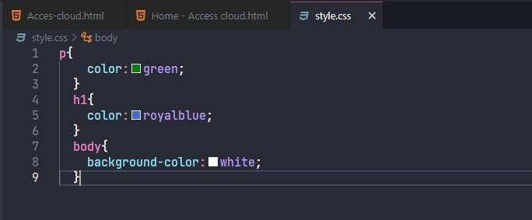

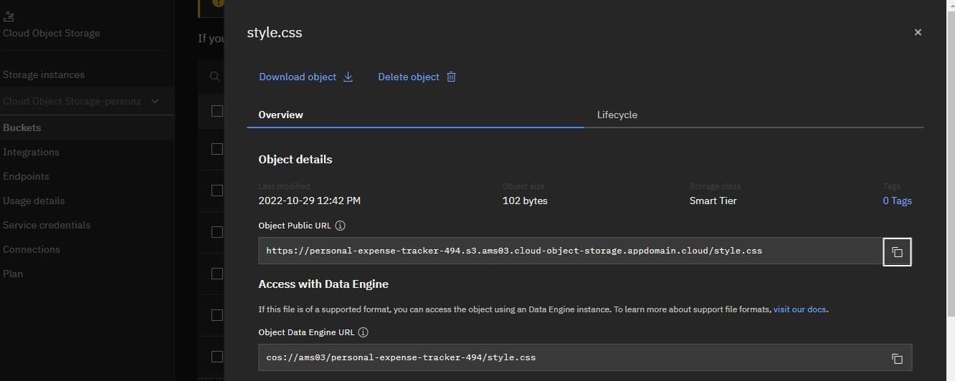

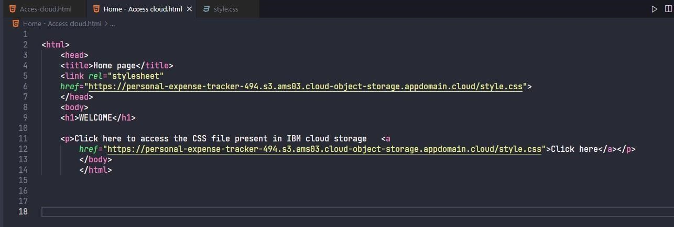

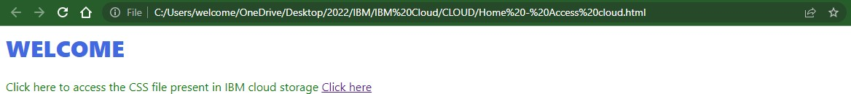

1. Design a chatbot using IBM Watson assistant for hospital. Ex: User comes with query to know the branches for that hospital in your city. Submit the web URL of that chat bot as an assignment.

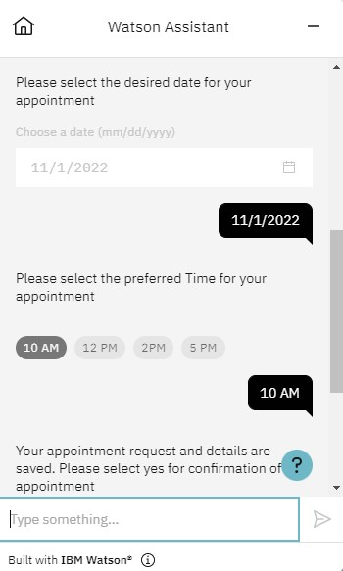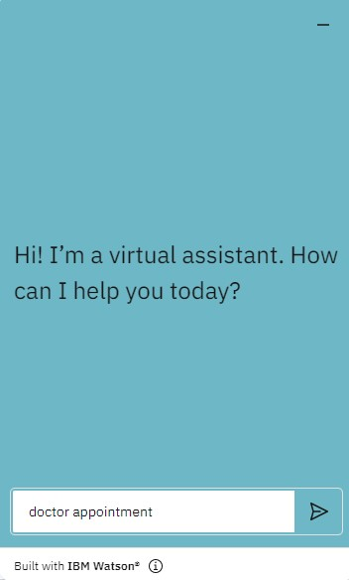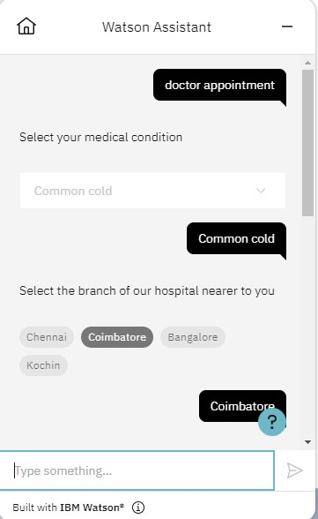

Watson Assistant —

appointment

# 1 2 PM 2PM 5 PI'4



Your appointment request and details are saved. Please select yes for confirmation of the appointment





! | Your Appointment for doctor consultation on Nov 1, 2022 at 10 Ai•1 has been Scheduled



Built with IBM Watson*

**5.** Create Watson assistant servicewith 10 steps and use 3 conditions in it. Load that script in HTMLpage.

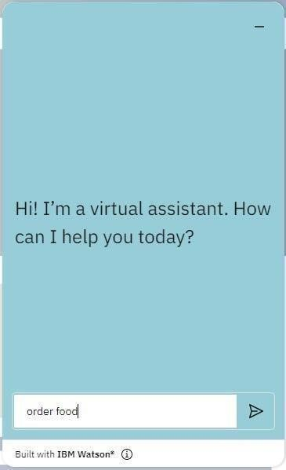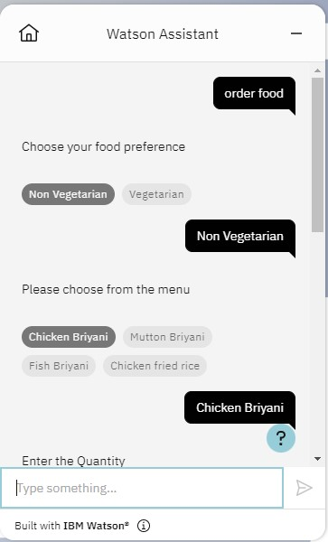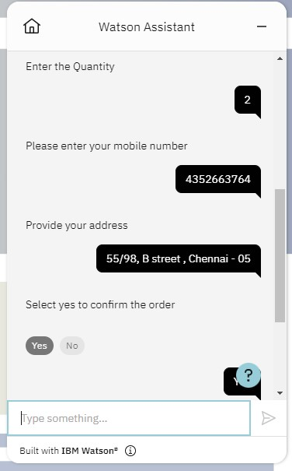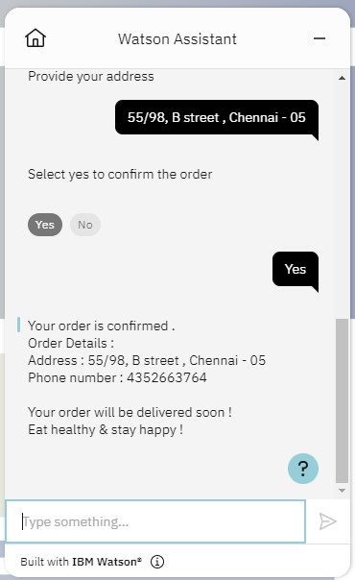

Script in HTML page:

